Cairo university  
Faculty of engineering  
Computer engineering department  
Computer graphics [**CMP3060**] project

Github repo link

<https://github.com/Mamdouh-Attia/Gamingo/tree/phase2>

**Drive Me Home**

**Team 7**

|  |  |  |  |
| --- | --- | --- | --- |
| Name | section | BN | ID |
| احمد مصطفى محمد محمد ابو العارف | 1 | 10 | 9202201 |
| عمر فريد عبد العاطى لملوم | 2 | 4 | 9202968 |
| معاذ محمد حسن بيومي | 2 | 26 | 9203532 |
| ممدوح احمد محمد محمد عطيه | 2 | 27 | 9203543 |

Presented to:

**Eng. Yehia Zakaria**

# **Work division between team members.**

|  |  |  |
| --- | --- | --- |
| Name | Phase 1 | Phase 2 |
| Ahmed Aref | Reqs 2,3,4 | * Adding Game objects * Car physics & controls * Components: fuel, obstacle and car |
| Omar Farid | Req 8 | * All of Lighting requirement * Documentation |
| Moaz Mohamed | Reqs 1,9,10,11 | * Adding Game objects * Collision system * Levels design * Health handling * Sound System * Contribution in Lighting |
| Mamdouh Ahmed | Reqs 1,5,6,7 | * Adding Game objects * Collision system * Level navigation systems * Menu, LevelUP, GameOver states * 4 Postprocessing shaders |

Integration and improvements are made by all team member together.

**Demo Video**

Please see this unlisted Youtube video, <https://www.youtube.com/watch?v=-o9Z7iQaBZQ>

# **Screenshots**

# **1) Menu**

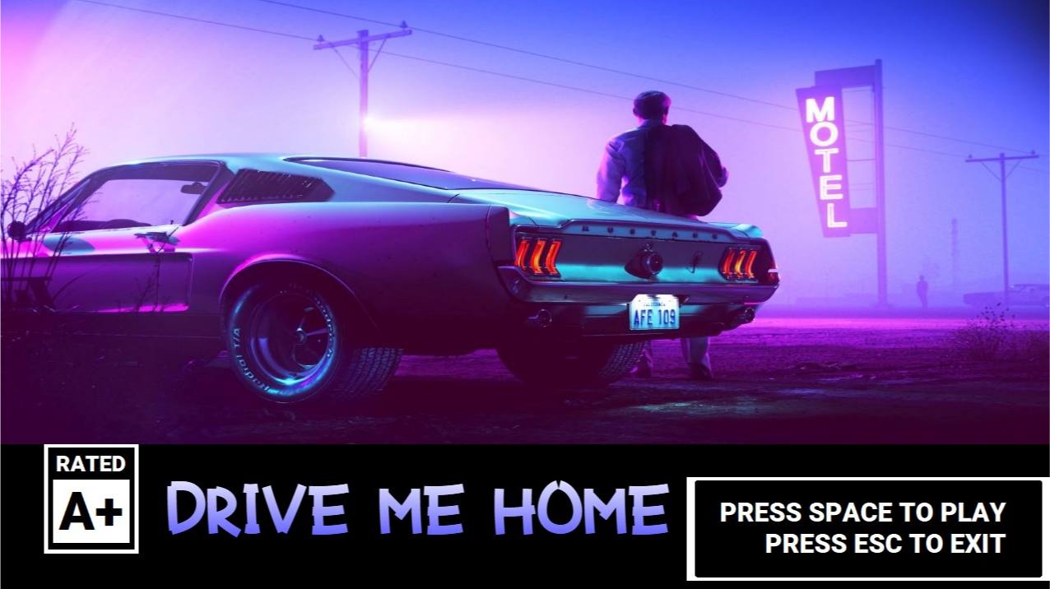

# **2) Level 1**

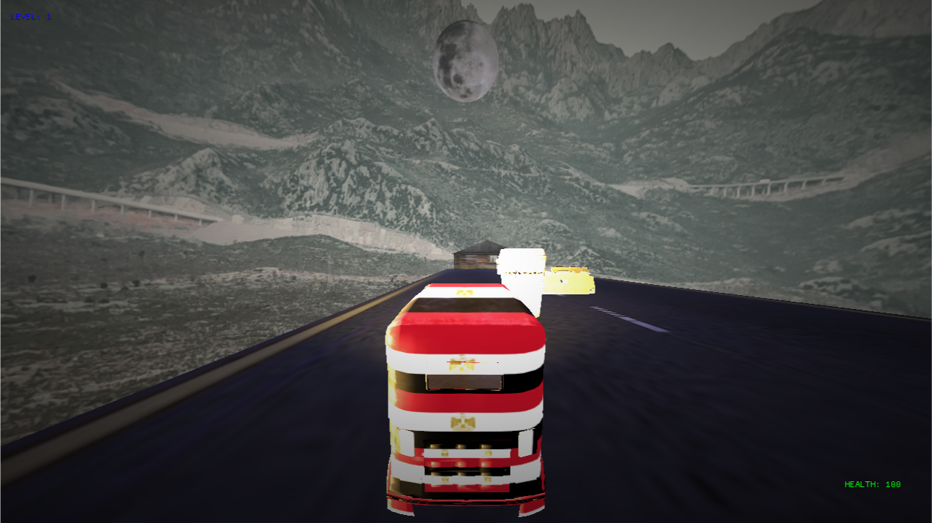

# **3) Finish**

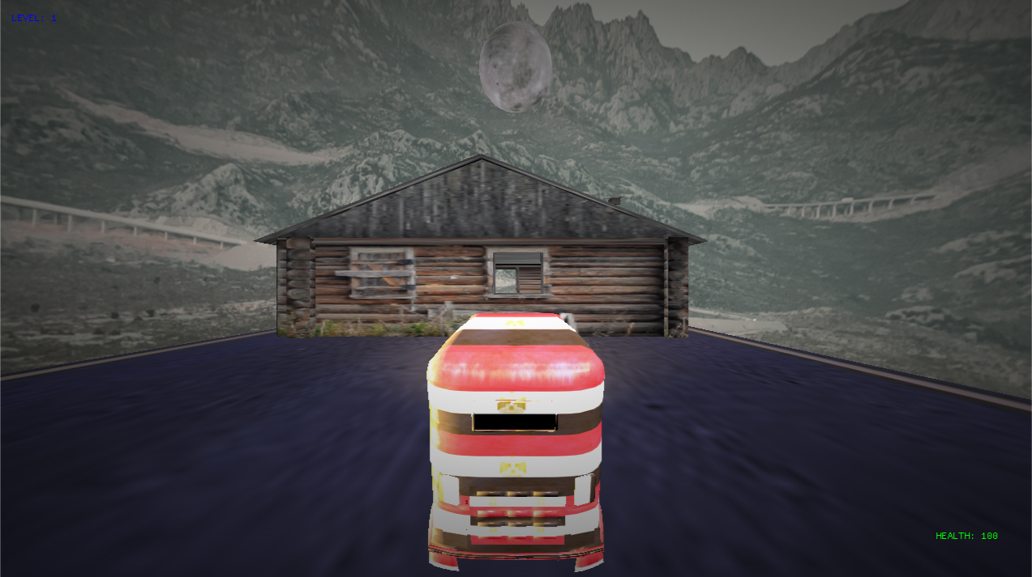

# **4) Level Up**

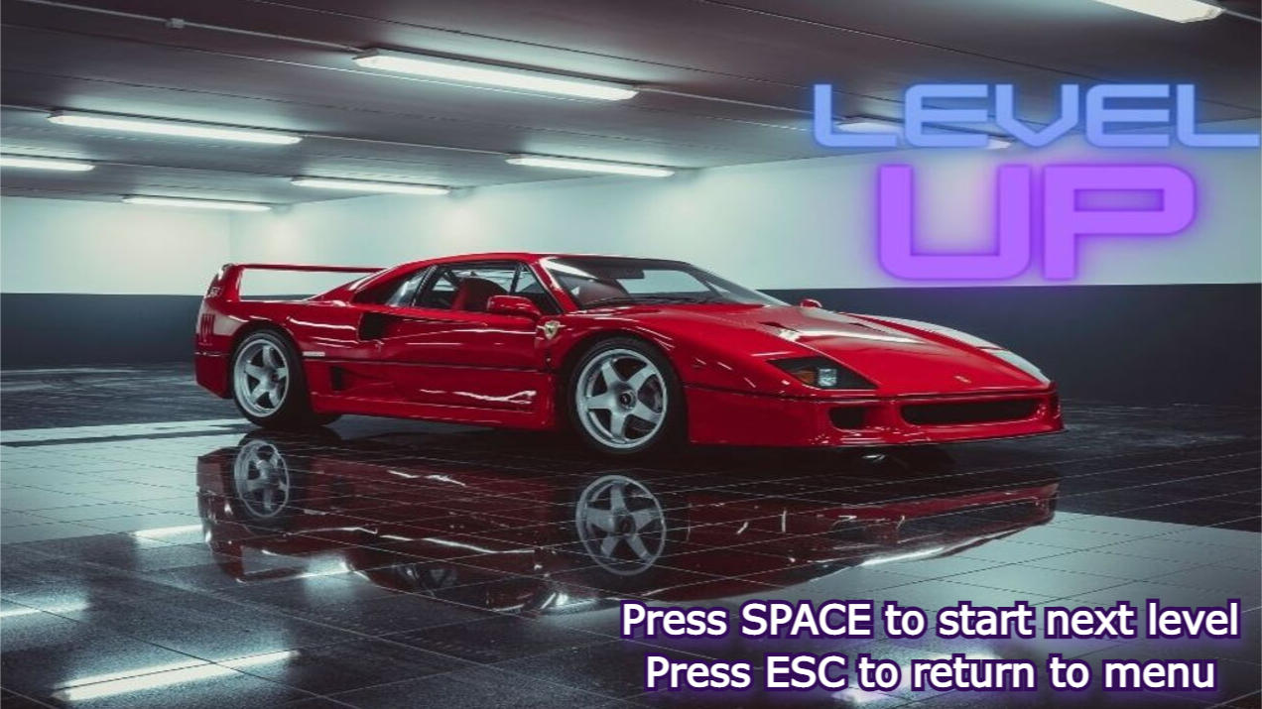

# **5) Level 2**

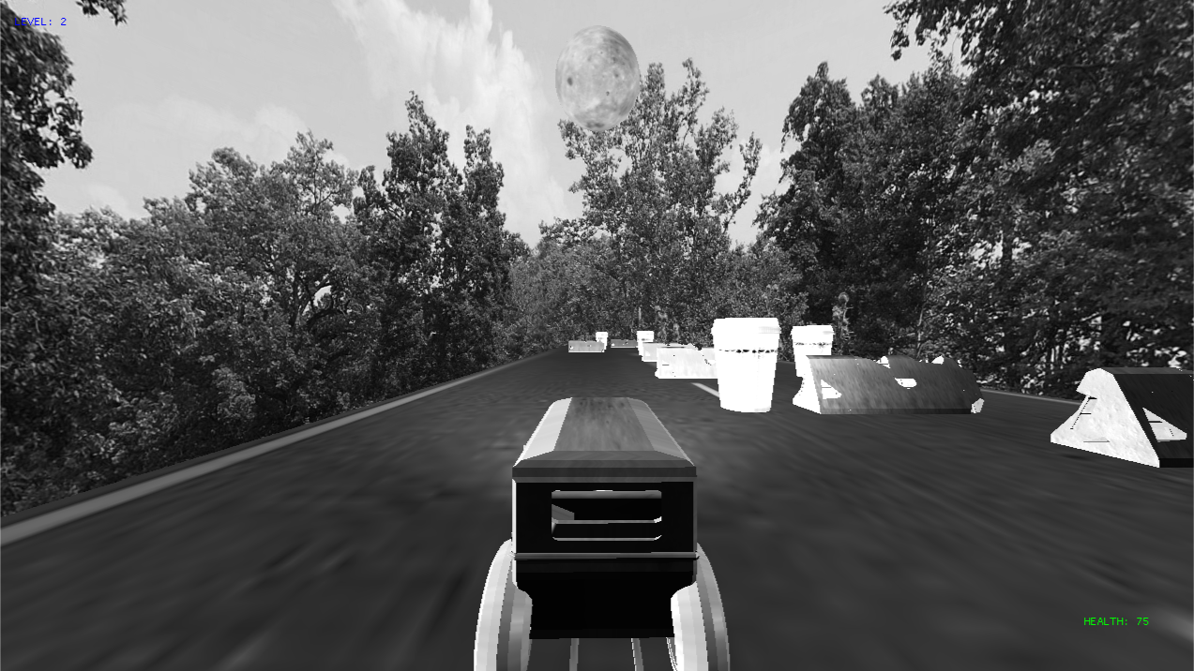

# **6) Level 3**

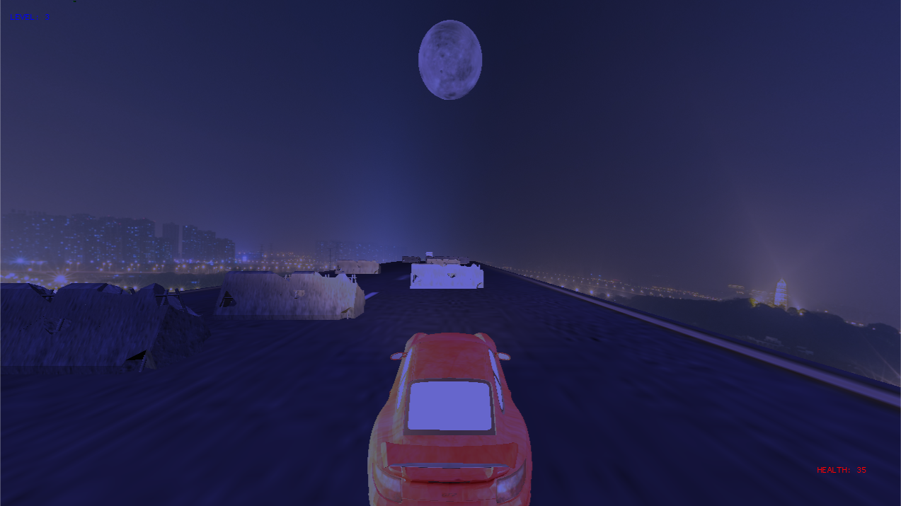

# **7) Game Over**

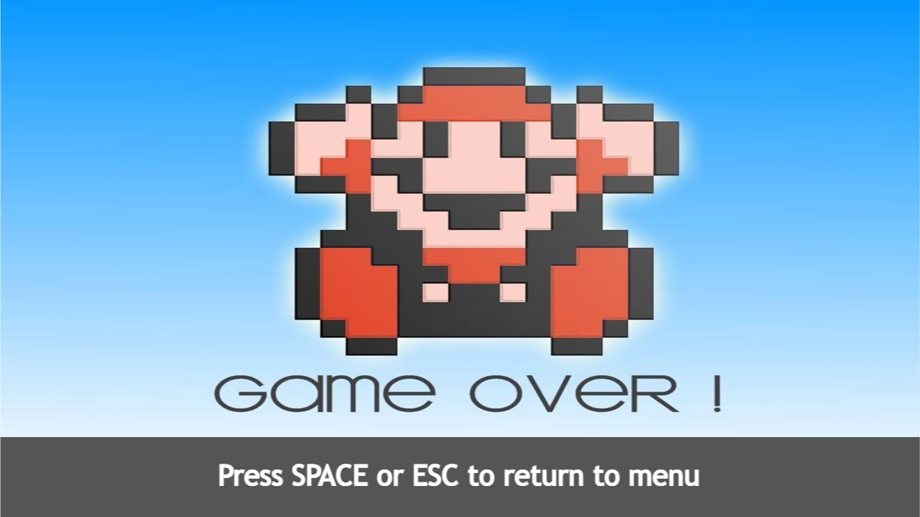

Thank You!